Biofluid Mechanics Final Project

Model of Coronary Arteries and Evaluation of the Effect of Stenosis on Flow Rates

Diego Alba Burbano
Table of Contents
Definition of Symbols 3
Background 4
Numerical Solution 5
Pressure and Volumetric Flow Rates 6
Average Flow Rates 7
Introducing Stenosis 7
Pressure and Volumetric Flow Rates 8
Average Flow Rates 9
Reduction in Flow Rate 9
Varying Stenosis 9
Average Flow Rate in LAD 9
Modeling Hyperemia 10
Pressure and Volumetric Flow Rates 11
Average Flow Rates 12
Comparison with Stenosis 12
References 13
Appendix 14
Numerical Solution Code 14
Runge-Kutta Method Code 16
Introducing Stenosis Code 17
Varying Stenosis Code 17
Modeling Hyperemia Code 18
MATLAB Files 19

Definition of Symbols
A | cross-sectional area of vessel
As | cross-sectional area of vessel after stenosis
α (alpha) | cross-sectional area change of the micro-vessel
C | capacitance
Cs | capacitance after stenosis
D | vessel diameter
Ds | vessel diameter after stenosis
DS | diameter stenosis percentage
E | Young’s modulus of the vessel
h | thickness of the vessel wall
L | inductance
Ls | inductance after stenosis
μ (mu) | viscosity
P | pressure
Pa | aortic pressure
Q | volumetric flow rate
R | resistance
Rs | resistance after stenosis
ρ (rho) | density
s | length of the vessel or branch
ss | length of the vessel after stenosis
t | time
T | period
Z | impedance

Background
In this project we will model a simplified network associated with the left coronary artery as an electric network circuit (Figure 1). Here L, R, and C are the inductance, resistance, and capacitance respectively, and they can be defined as:
$$L=\frac{ρs}{A}, R=\frac{8πμs}{A^{2}}, C=\frac{AsD}{Eh}$$
Additionally, the micro-vessels are model by time-varying impedance, $Z\left(t\right)=Z0/α{\left(t\right)}^{2}$, where $α(t)$, is a function that models the cross-sectional area change of the micro-vessels.
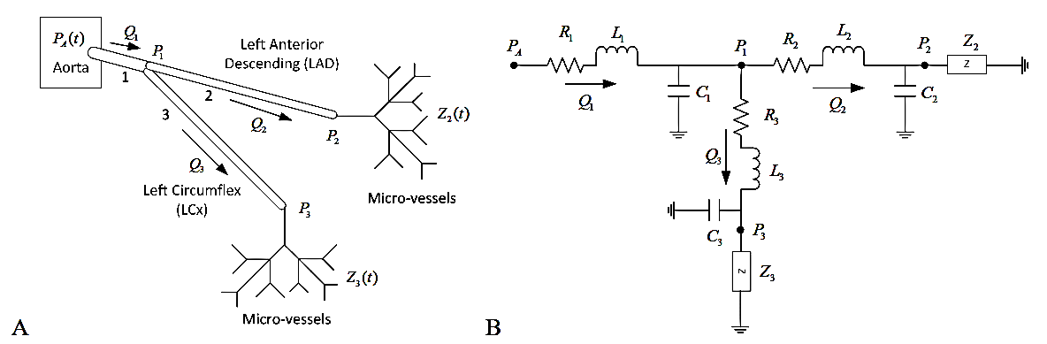
Figure 1. A: Simplified left coronary artery tree for the Left Coronary Artery;
B: Analogous electric network circuit.
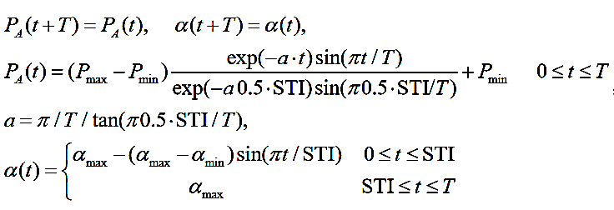
The time-varying aortic pressure, $P_{A}(t)$, and the micro-vessel cross-sectional area variation are periodic functions that can be model as:

The solution to these equations is show in Figure 2, in the Numerical Solution section.
Note: all necessary constants with units are given in the Appendix.
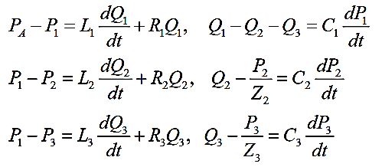
Finally, we can derive the differential equations for pressure and volumetric flow rate for each of three arteries in the system:

Numerical Solution
Solving the system of six differential equations using the Runge-Kutta Method Code (see Appendix), and using the parameters tabulated below, we can fin the pressure and volumetric flow rate of each vessel over time.
$P_{min}$= 106658 Ba | $α_{min}$ = 0.2
$P_{max}$= 159987 Ba | $α_{max}$ = 1
HR = 70 BPM | Cycles = 10
$P_{0}$ = $P_{min}, ∀$ vessels | $Q_{0}$ = $0, ∀$ vessels

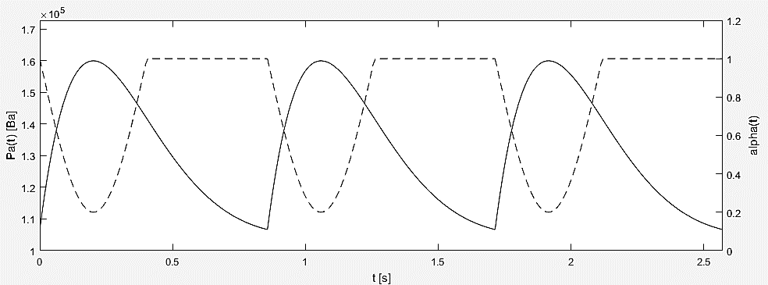
First, we can solve for the aortic pressure and the micro-vessel cross-sectional area over time (three periods).
Figure 2: Time-varying aortic pressure and micro-vessel cross sectional area over three periods.

Pressure and Volumetric Flow Rates
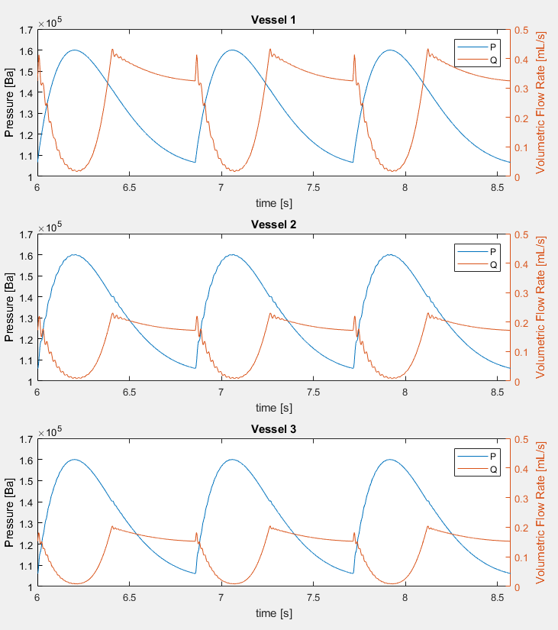
The solution to the system of six ODEs is presented below. Only the last three of the ten calculated periods are shown.
Figure 3: Pressure and volumetric flow rate over time for the three vessels of the model.
Vessel 2 corresponds with LAD and Vessel 3 with LCx.

Average Flow Rates
The calculated average flow rates were 0.1348 mL/s and 0.1193 mL/s for the left anterior descending artery (LAD) and the left circumflex artery (LCx), respectively. These values fall within the empirical range of 0.30 ± 0.22 mL/s for the LAD [1], as well as in the range of 28.4 ± 19.7 mL/min in the LCx [2]. Note that for the second comparison, flow rates should be converted to mL/s. These indicates that the model is not too far off the actual measurements, although it is closer to the lower bounds.

Introducing Stenosis
We can study the effects of stenosis (Figure 4) in the arteries by modifying the inductance, resistance, and capacitance of the system. The new parameters are:

$$Ls=ρ( \frac{s_{s}}{A_{s}}+\frac{s-s_{s}}{A} ), Rs=8πμ( \frac{s_{s}}{A_{s}^{2}}+\frac{s-s_{s}}{A^{2}} ), Cs=\frac{A(s-s_{s})D}{Eh}, A_{s}=\frac{πD_{s}^{2}}{4}$$
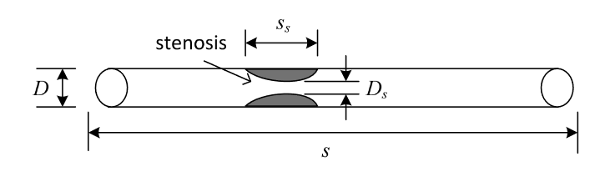
Figure 4: Diagram of vessel diameter reduction by stenosis.

If we set $s_{s}$ equal to 2cm and $D_{s}$ to 30% of the original diameter in LAD (Vessel 2), we can repeat the analysis done in the previous section for the case without stenosis.

Pressure and Volumetric Flow Rates
The solution to the system of six ODEs, this time with stenosis in the second vessel, is presented below. Only the last three of the ten calculated periods are shown.

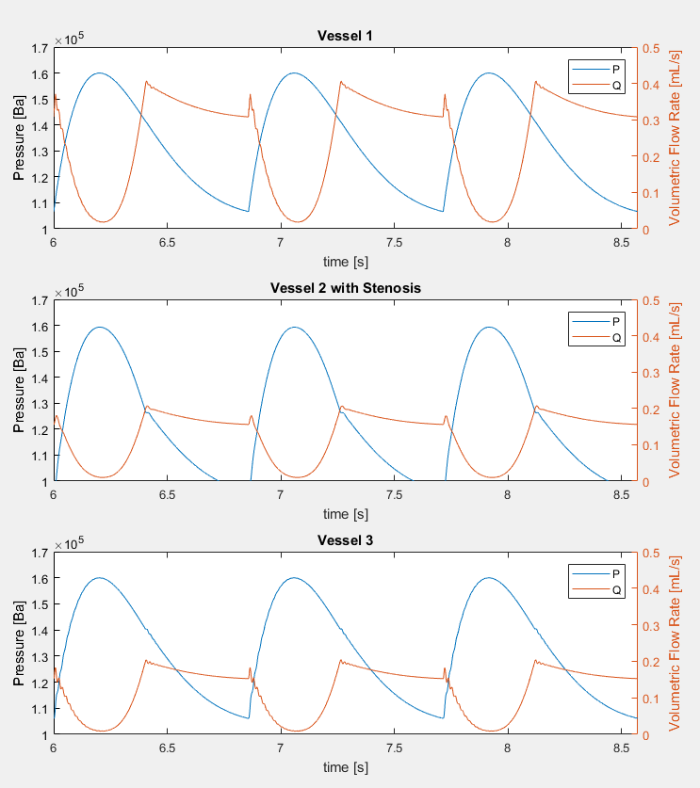
Figure 5: Pressure and volumetric flow rate over time for the three vessels of the model.
Vessel 2 corresponds with LAD and Vessel 3 with LCx. Vessel 2 has stenosis.

Average Flow Rates
The calculated average flow rates were 0.1233 mL/s and 0.1193 mL/s for the left anterior descending artery (LAD) and the left circumflex artery (LCx), respectively. Even though the average flow rate in LAD decreases with stenosis, the value is still within the range found in the literature [1]. This could be due to the fact that 30% reduction in diameter does not affect the flow rate severely.

Reduction in Flow Rate
With a 30% decrease in vessel diameter, the reduction in average volumetric flow rate in LAD is less than 10%, precisely 8.53%. Stenosis in vessel 2 did not affect LCx flow rate, as the average volumetric flow rate was in both scenarios 0.1193 mL/s.

Varying Stenosis
To further investigate the effects of stenosis in the volumetric flow rate, the reduction in diameter was increased from 50% reduction to 90% reduction, and the average volumetric flow rate was calculated for each reduced diameter. Here, we define the diameter stenosis percentage, DS, as $DS=\left( \frac{D-D_{s}}{D}\right)*100$, where $D_{s}$ is the reduced diameter. $s_{s}$ was maintained at 2cm, as in the previous analysis. The results are shown below (Figure 6).

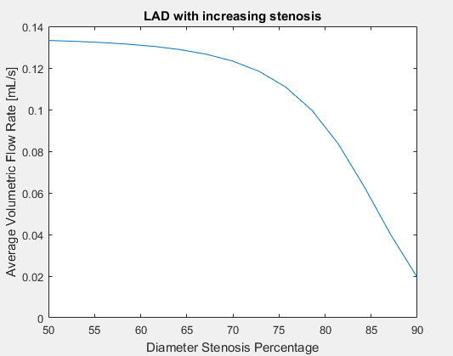
Average Flow Rate in LAD
Figure 6: Average volumetric flow rate in LAD as a function of increasing stenosis.

These results make sense, since the volumetric flow rate should decrease as the vessel gets more and more obstructed. One can really appreciate how this decrease is barely noticeable until a ~70% of reduction in the vessel diameter is achieved, when the flow rate starts decreasing steeply.
The only publish data available reports the following results [3]:
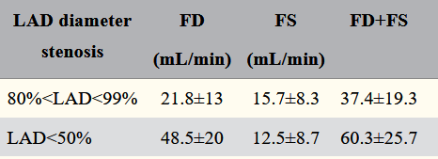
Figure 7: LAD, left anterior descending coronary artery; FD, diastolic flow; FS, systolic flow;
(FD+FS), sum of diastolic and systolic (total) flow (mL/min).

This data leads us to conclude that there a ~37%-57% reduction in volumetric flow rate when stenosis goes from not severe (50%) to severe (>80%, as defined in the original paper). Our model also predicts a ~37% reduction in volumetric flow rate when going from 50% to 80% stenosis, where reduction is defined as ($reduction=(1-\frac{Q(80\%)}{Q(50\%)}$)*100$= (1-\frac{0.08356}{0.1332}$)*100 = 37.27%).

Modeling Hyperemia
Drugs can be used to induced the dilation of small capillaries (a phenomenon called hyperemia), which would decrease the impedance these small vessels cause on blood flow, thereby increasing the volumetric flow rate. With an increase in flow rate, the reduction in flow caused by stenosis should be easier to observe. This is the hypothesis we will test in this section. Here we assume the impedance drops by 80% when hyperemia is induced.
We will carry on a similar analysis than in previous sections: evaluate the pressure and volumetric flow rates of the three vessels, with no stenosis; calculate the average flow rates and compare it to values found in the literature; and compare the reduction in flow rate with stenosis and with both stenosis and hyperemia.

Pressure and Volumetric Flow Rates
The solution to the system of six ODEs, this time with hyperemia in the second and third vessels, is presented below. Only the last three of the ten calculated periods are shown.
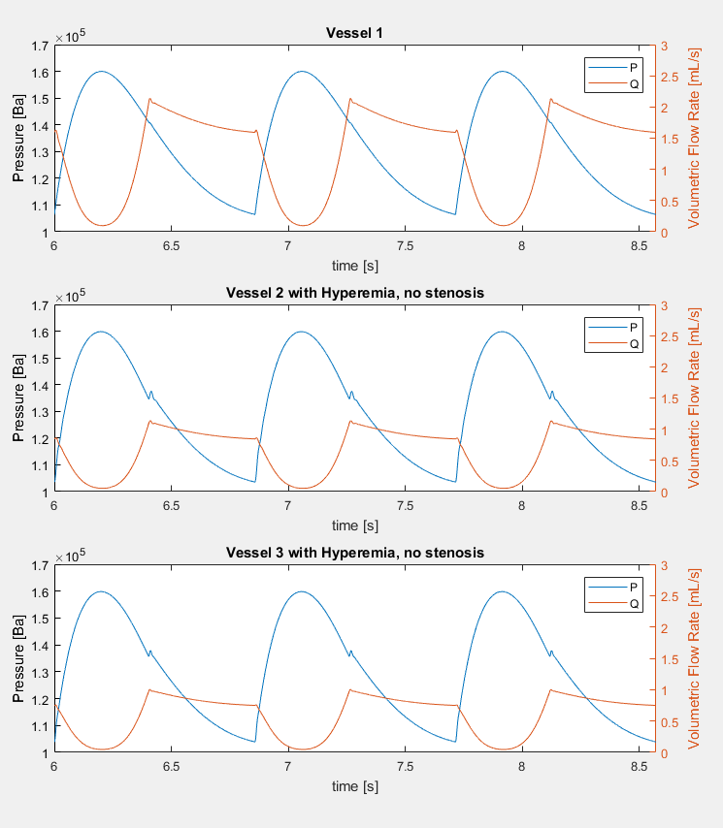
Figure 8: Pressure and volumetric flow rate over time for the three vessels of the model.
Vessel 2 corresponds with LAD and Vessel 3 with LCx. Vessels 2 and 3 have hyperemia.

Average Flow Rates
The calculated average flow rates were 0.6596 mL/s and 0.5853 mL/s for the left anterior descending artery (LAD) and the left circumflex artery (LCx), respectively. We can appreciate how hyperemia induces much higher flow rates by reducing the impedance produced by the micro-vessels.

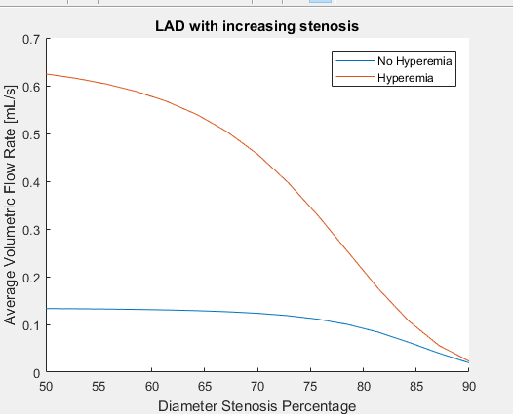
Comparison with Stenosis
Figure 9: Average flow rate with increasing stenosis. It’s clear the drop in flow is much more noticeable in the case with hyperemia.

From Figure 9 we can infer our hypothesis was correct: it is easier to detect stenosis if hyperemia is induced, since the average flow rate will be higher and therefore the reduction in it will be more drastic. Therefore, testing for stenosis under hyperemia will provide better indicator of coronary blockage.

References
[1] Marcus, J. Tim, et al. “Flow Profiles in the Left Anterior Descending and the Right Coronary Artery Assessed by MR Velocity Quantification: Effects of Through-Plane and In-Plane Motion of the Heart.” Journal of Computer Assisted Tomography, vol. 23, no. 4, 1999, pp. 567–576., doi:10.1097/00004728-199907000-00017.
[2] Johnson, Kevin, et al. “Coronary Artery Flow Measurement Using Navigator Echo Gated Phase Contrast Magnetic Resonance Velocity Mapping at 3.0T.” Journal of Biomechanics, vol. 41, no. 3, 2008, pp. 595–602., doi:10.1016/j.jbiomech.2007.10.010.
[3] Sharif, Dawod Saleh, et al. “Detection of Severe Left Anterior Descending Coronary Artery Stenosis by Transthoracic Evaluation of Resting Coronary Flow Velocity Dynamics.” Heart International, vol. 5, no. 2, 2010, doi:10.4081/hi.2010.e10.

Appendix
Note that all symbols match the definitions used in the report and described in the section Definition of Symbols.

Numerical Solution Code
First, we define some parameters given in the prompt of the assignment and that will stay constant throughout the different sections of the modeling.

% data
D = [0.4 0.28 0.26]; % cm
s = [2.2 13 9.6]; % cm
Z0 = [0 612901 692846]; % Ba s/mL

rho = 1.0; % g/cm^3
mu = 0.04; % Ba*s
E = 2*10^8; % Ba

A = pi*D.^2/4; % cm^2
h = 0.08*D; % cm

Pmax = 159987; % Ba
Pmin = 106658; % Ba
alphamin = 0.2;
alphamax = 1;
HR = 70; % BPM

T = 60/HR;
STI = (-2.1*HR+550)/1000;
a = pi/T/tan(pi*0.5*STI/T);

Pa = @(t) (Pmax-Pmin)*(exp(-a.*t).*sin(pi.*t/T))./...
(exp(-a.*0.5*STI).*sin(pi*0.5*STI/T))+Pmin;

alpha = @(t) alphamax - (alphamax- alphamin)*
sin(pi*t.*(t<STI)/STI);

% define Inductance, Resistance, and Capacitance
L = rho*s./A;
R = 8*pi*mu*s./A.^2;
C = (A.*s.*D)./(E*h);

The following code was used to generate Figure 2, and to match the figure in the assignment to demonstrate the functionality of the code for the aortic pressure and the micro-vessel cross-sectional area variation.

t = linspace(0,T);
figure('Position',[388 445 1129 366])
plot(t,Pa(t),'k',t+T,Pa(t),'k',t+2*T,Pa(t),'k')
ylim([round(Pmin,-5),Pmax*1.08])
ylabel('Pa(t) [Ba]')
yyaxis right
plot(t,alpha(t),'k--',t+T,alpha(t),'k--',t+2*T,alpha(t),'k--')
ylim([0,alphamax*1.2])
ylabel('alpha(t)')
ax = gca;
ax.YColor = 'black';
xlim([0,T*3])
xlabel('t [s]')

Next, we define the time-varying impedance for Vessel 2 and Vessel 3, prior to introducing hyperemia in the model. The differential equations that model the analogous electric network circuit of the arteries are also defined in this section, and the initial conditions for all ODEs are set. Then, the custom function RK4 (Runge-Kutta) is used to solve the system of equations for 10 periods. The code for this function is provided in the next section. Then, the last 3 periods for all of the vessels are plotted, and the average volumetric flow rates are calculated.

Z2 =@(t) Z0(2)./(alpha(t)).^2;
Z3 =@(t) Z0(3)./(alpha(t)).^2;

dQ1dt =@(t,Q,P) (1/L(1))*(Pa(t)-P(1)-R(1)*Q(1));
dQ2dt =@(t,Q,P) (1/L(2))*(P(1)-P(2)-R(2)*Q(2));
dQ3dt =@(t,Q,P) (1/L(3))*(P(1)-P(3)-R(3)*Q(3));

dP1dt =@(t,Q,P) (Q(1)-Q(2)-Q(3))/C(1);
dP2dt =@(t,Q,P) (Q(2)-P(2)/Z2(t))/C(2);
dP3dt =@(t,Q,P) (Q(3)-P(3)/Z3(t))/C(3);

sys = {dQ1dt dQ2dt dQ3dt dP1dt dP2dt dP3dt};
Q0 = [0 0 0]';
P0 = [Pmin Pmin Pmin]';

[t,Q,P] = RK4(sys,Q0,P0,T,10*T);
r = 10000*[7 10];
figure('Position',[680 83 800 895])
for i = 1:3
subplot(3,1,i)
plot(t(r(1):r(2)),P(i,r(1):r(2)))
ylabel('Pressure [Ba]')
ylim([10^5 1.7*10^5])
yyaxis right
plot(t(r(1):r(2)),Q(i,r(1):r(2)))
ylabel('Volumetric Flow Rate [mL/s]')
ylim([0 0.5])
title(['Vessel ',num2str(i)])
legend('P','Q')
xlim(t(r))
xlabel('time [s]')
end

% Average flow rates in LAD and LCx
Q_LAD = mean(Q(2,:));
Q_LCx = mean(Q(3,:));

Runge-Kutta Method Code
Here we present the custom Runge-Kutta function used to solve the system of differential equations. It takes the six functions previously defined, the initial conditions, the period, and the time span to solve for as inputs, and outputs a time vector and the calculated volumetric flow rates and pressures for each vessel for each corresponding time point.

% Runge-Kutta Method
function [tall,Q,P] = RK4(ode, Q0, P0, T, tspan)
n = 10000;
dt = T/n;
c = tspan/T; % number of cycles
t = dt*(0:(n-1));

tall = zeros(1,n*c);
Q = NaN(length(Q0),n*c);
P = NaN(length(P0),n*c);

Q(:,1) = Q0;
P(:,1) = P0;

l = 1;
for i = 1:(n*c-1) % loop through time
dQ = Q(:,i);
dP = P(:,i);
for k =0:3 % loop through RK
for j = 1:length(Q0) % loop through vessels
dP(j) = P(j,i) + (1/(4- k))*dt*
ode{j+length(P0)}(t(l),dQ,dP);
dQ(j) = Q(j,i) + (1/(4- k))*dt*
ode{j}(t(l),dQ,dP);
end
end
tall(i+1) = tall(i)+dt;
Q(:,i+1) = dQ;
P(:,i+1) = dP;
l = l*(l~=n)+1;
end
end

Introducing Stenosis Code
In this part of the code, the definitions of cross-sectional area, inductance, resistance, and capacitance are modified to include the possibility of stenosis in the arteries. Moreover, stenosis is introduced into Vessel 2. These new definitions are used to recalculate the volumetric flows and pressures in each vessel in the same manner as in the Numerical Solution Code section.

% Recalculate with Stenosis
As =@(Ds) pi*Ds.^2/4;
Ls =@(ss,Ds) rho*(ss./As(Ds) + (s-ss)./A);
Rs =@(ss,Ds) 8*pi*mu*(ss./(As(Ds)).^2 +(s-ss)./A.^2);
Cs =@(ss,Ds) A.*(s-ss).*D./(E*h);

% stenosis only in LAD
ss = [0 2 0];
Ds = [D(1) 0.3*D(2) D(3)];
L = Ls(ss,Ds);
R = Rs(ss,Ds);
C = Cs(ss,Ds);

Varying Stenosis Code
In this section we define the diameter stenosis percentage, DS, and make the diameter, Dss, a function of DS. This will let us calculate different artery diameters for various levels of stenosis. We increase the diameter stenosis percentage from 50% to 90% in 15 steps and calculate the average volumetric flow rate in Vessel 2. Then we plot the calculated average volumetric flow rate as a function of the diameter stenosis percentage.

% Varying stenosis percentage
Dss =@(DS) D(2)-(DS/100).*D(2);
DS = linspace(50,90,15);
Q_LADs = zeros(2,length(DS));
ss = [0 2 0];

for i = 1:length(DS)
Ds = [D(1) Dss(DS(i)) D(3)];
L = Ls(ss,Ds);
R = Rs(ss,Ds);
C = Cs(ss,Ds);

dQ1dt =@(t,Q,P) (1/L(1))*(Pa(t)-P(1)-R(1)*Q(1));
dQ2dt =@(t,Q,P) (1/L(2))*(P(1)-P(2)-R(2)*Q(2));
dQ3dt =@(t,Q,P) (1/L(3))*(P(1)-P(3)-R(3)*Q(3));

dP1dt =@(t,Q,P) (Q(1)-Q(2)-Q(3))/C(1);
dP2dt =@(t,Q,P) (Q(2)-P(2)/Z2(t))/C(2);
dP3dt =@(t,Q,P) (Q(3)-P(3)/Z3(t))/C(3);

sys = {dQ1dt dQ2dt dQ3dt dP1dt dP2dt dP3dt};
[~,Q,~] = RK4(sys,Q0,P0,T,10*T);

Q_LADs(1,i) = mean(Q(2,:));
end
figure
plot(DS,Q_LADs(1,:))
xlabel('Diameter Stenosis Percentage')
ylabel('Average Volumetric Flow Rate [mL/s]')
title('LAD with increasing stenosis')

Modeling Hyperemia Code
In order to model the effects of hyperemia, we modify the impedance of the vessels to be 20% of the original. We will first model hyperemia alone, with no stenosis. The same code as in the section Numerical Solution Code is used to calculate the volumetric flow rates and pressures for all vessels.

% Hyperemia
Z0 = 0.2*Z0;
Z2 =@(t) Z0(2)./(alpha(t)).^2;
Z3 =@(t) Z0(3)./(alpha(t)).^2;
ss = [0 0 0]; % no stenosis

Lastly, to compare the two scenarios (hyperemia alone, and both stenosis and hyperemia) we introduce stenosis in Vessel 2 and calculate the average volumetric flow rates using the code in the Varying Stenosis Code section.

ss = [0 2 0];
figure
hold on
plot(DS,Q_LADs(1,:))
plot(DS,Q_LADs(2,:))
legend('No Hyperemia','Hyperemia')
xlabel('Diameter Stenosis Percentage')
ylabel('Average Volumetric Flow Rate [mL/s]')
title('LAD with increasing stenosis')

MATLAB Files
All MATLAB files used in this report are available in the link below. Each file can run independently (the custom function RK4 is needed) and produce the desired results for each section. https://livejohnshopkins-my.sharepoint.com/:f:/g/personal/dalbabu1_jh_edu/EjEX6q826LBHjIe-CnCMx9QBa_JLC9iY0kYr6jP38wglLQ?e=dIMDDd

